

Agile Business Analysis

Project: Sprout-Scout

Simon Wild

November 08, 2019

**Master of Science in Business Information Systems**

# Table of Contents

Table of Contents I

1. Introduction to the module 1

2. Theory in the course 2

List of Figures / Tables 3

Figures 3

Tables 3

# Introduction to the module

5 to 6 Pages

What was my role in the project?

What was my contribution

What were my learnings? Relate them to the knowledge areas and to the principles of agility

# Project Sprout-Scout

The goal of this project is to evaluate a possible improvement of skill and knowledge-based matching, between students and the industry, using machine learning algorithms. Artificial Intelligence (AI) and Machine Learing (ML) are the field of embedding the human way of thinking and making connections into a computer program.

There are a lot of different job posting platforms as well as a lot of different head-hunter boutiques. Some sites are traditional jobs boards like Monster, Dice, Jobs.ch, Glassdoor and CareerBuilder. Others, like Indeed.com, “Google for Jobs” and SimplyHired.com take advantage the traditional job sites and allow you to search though many of them at the same time. For the job seeker, the platform do not differ much in terms of usability. The dominant features the job seeker can search for are:

* Job title
* Key words
* Company
* Type of employment (Full-time / part-time / internship / trainee)
* Location
* Salary

The business model which should be evaluated is displayed in Figure 1. The focus in this project lays on the evaluation of the idea of profile matching based on the feature extraction. The customer segment is restricted to the students of the FHNW in the study program BIS.

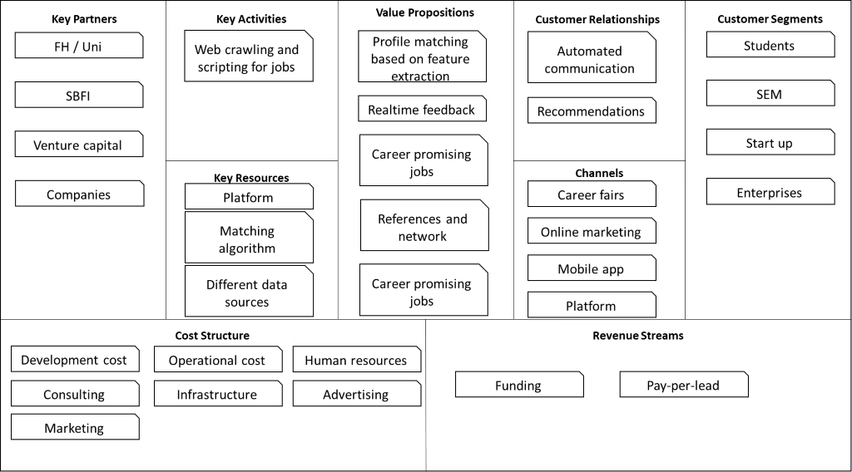

Figure 1: Business Model Canvas

In this written report of the module and the project, the focus lays on the design process of the product.

## Theory in the course

The BABOK Guide consists of 6 knowledge areas: Business Analysis Planning and Monitoring, Elicitation and Collaboration, Requirements Life Cycle Management, Strategy Analysis, Requirements Analysis and Design Definition (RADD) and Solution Evaluation. These knowledge areas describe the practices of business analysis as applied within a project at a company. Knowledge areas are a collection of logically related tasks. Since the design of the solution is in the spotlight for this report, the knowledge area focused on is Requirements Analysis and Design Definition. Both the requirements and design are important tools to define a change or a product. The main difference between requirements and designs is in how they are used. Both the scope and the solution where not defined in de beginning and had therefore to be handled in a agile matter ( see Figure 2).

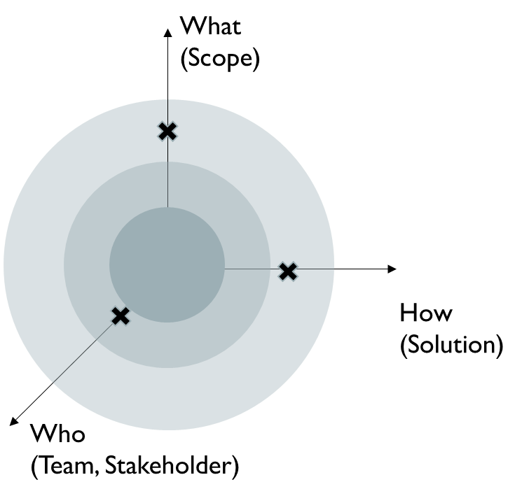

Figure 2: Demand for an agile approach

The first step is to empathize, define and the ideate over the possible business model. After this design thinking process the first prototypes can be build and a feedback can be gathered. This is also shown in Figure 3 where the first design iteration starts right after the ideate phase in the prototyping task.

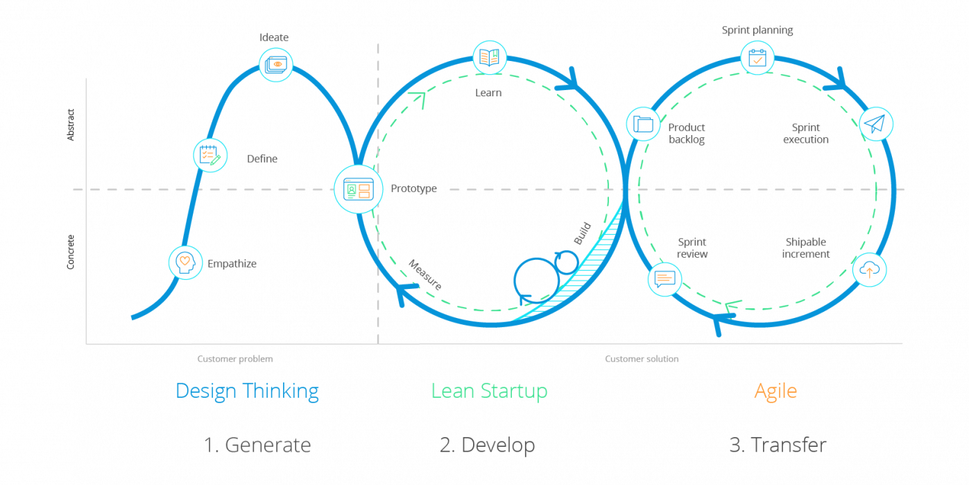

Figure 3: Design Thinking, Lean Start-up and Agile

## Practical application

## Overall impression

# List of Figures / Tables

# Figures

Figure 1: Mind map of PORP. 2

# Tables

Table 1: Advantages and disadvantages of start-ups 2